STATE OF THE INDUSTRY · SEPTEMBER 2026
Aging in Place 2026
Three in four adults over 50 want to stay home. Fewer than four in a hundred homes are ready.

64.6M  Americans aged 65+ in 2025 | 4.18M  turned 65 in 2025, a record | 2029  older adults outnumber children | $6,200  median monthly assisted living rate | 63M  unpaid family caregivers | $14.9T  home equity held by owners 62+

The bottom line
- Demand is locked in. 64.6 million Americans were 65 or older in 2025, up 16.2 percent since 2020, and a record 4.18 million turned 65 in 2025 alone. Older adults outnumber children from 2029.
- The homes are not ready. 75 percent of adults 50 and older want to stay in their current home, yet fewer than 4 percent of homes combine single-floor living, a no-step entry and wide halls and doorways.
- Staying home is mostly self-funded. Medicaid pays 61 percent of formal long-term care, but only after people spend down, and few payers cover home modifications. Owners 62 and older hold a record $14.92 trillion of home equity.
- Home care wins on price only part-time. At the $35 national median, in-home help costs more than the $6,200 assisted living median once it passes about 41 hours a week.
- The remodeling niche is open. Only 56 percent of remodelers do aging-in-place work, the lowest share since 2004, while 73 percent say requests are rising.

Who is coming, and who pays
FIGURE 1 Americans aged 65+ and 85+, millions  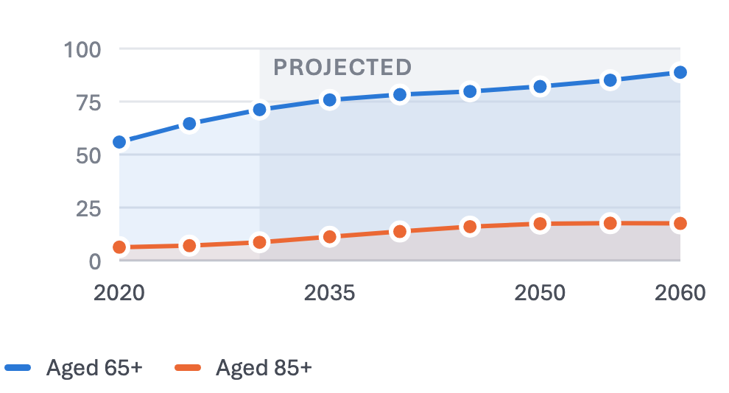  Census Bureau estimates to 2025; 2023 projections from 2030 (shaded). The 85+ group roughly doubles between 2025 and 2040. |  | FIGURE 2 Who pays for long-term care  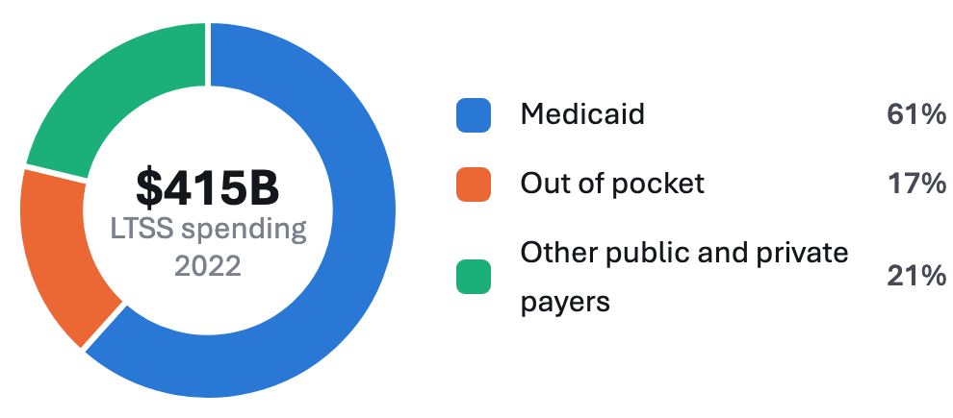  KFF, 2022. The 2023 total was $459 billion, Medicaid still 61 percent. Excludes Medicare post-acute care.  Few payers cover home modifications, so families pay for them from savings, income and home equity.

The cost of care: the honest math
FIGURE 3 Monthly cost of home care by weekly hours  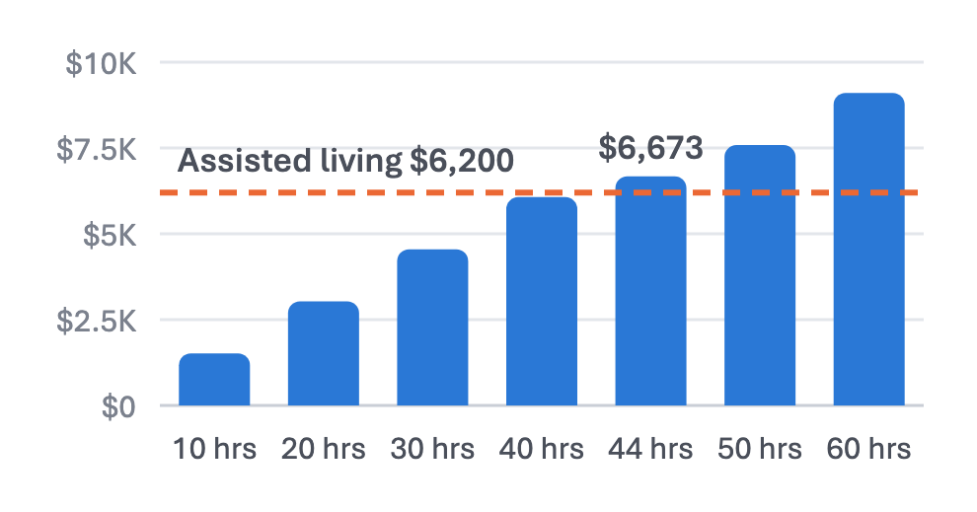  CareScout 2025 national medians. Monthly cost = $35 × hours × 52 ÷ 12. |  | 2025 median monthly costs  At 44 hours a week, in-home care costs more than assisted living in 34 of 50 states. Below about 41 hours it is cheaper everywhere, and most families buy help for part of the day, not all of it.  CareScout Cost of Care Survey 2025, July to November 2025, 387 metro areas. Home care is priced at $35 an hour. No figures are published for the District of Columbia, or for private nursing rooms in Alaska.
  Setting | US median | Highest | Lowest
  Assisted living | $6,200 | HI $12,096 | MS $4,369
  Home care, 44 hours a week | $6,673 | WY $8,771 | MS $4,576
  Nursing home, semi-private | $9,581 | AK $27,831 | TX $5,627
  Nursing home, private | $10,798 | OR $18,448 | TX $7,604

Where the opportunity is
FIGURE 4 Aging-in-Place Opportunity Index by state  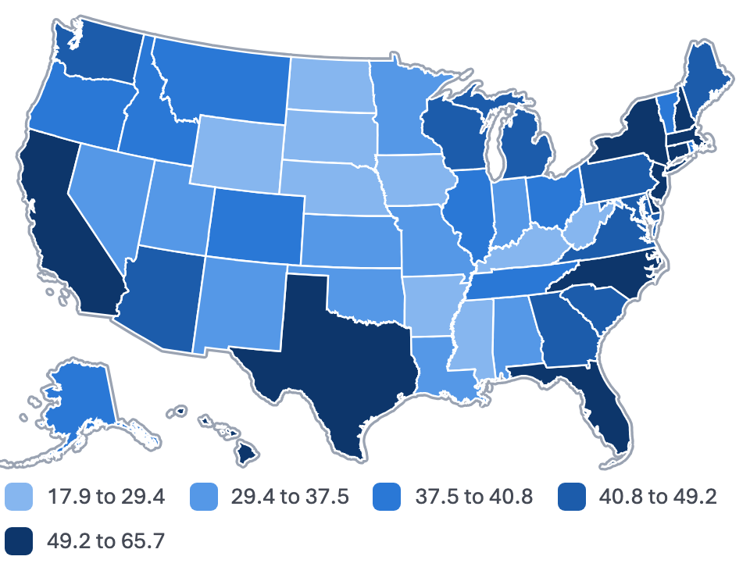  Five equal-count bands; darker scores higher. Census Vintage 2025, CareScout 2025 and Zillow Home Value Index, July 2026. |  | Top 10 states  Oldest: Maine 24.6%, Vermont 24.1%, Hawaii 23.3% aged 65+.  Fastest 65+ growth, 2020 to 2025: Delaware 23.4%, New Hampshire 21.5%, Idaho 21.0%.  Opportunity Index: this report’s composite of 65+ population and growth, share aged 75+, the care cost gap and home values. It is not a quality-of-life ranking.
  # | State | Index | 65+ share | 65+ growth
  1 | California | 65.7 | 17.6% | 14.6%
  2 | Florida | 63.7 | 22.9% | 16.7%
  3 | Hawaii | 61.7 | 23.3% | 14.5%
  4 | New York | 55.9 | 19.3% | 14.1%
  5 | Massachusetts | 55.6 | 19.9% | 15.6%
  6 | Texas | 52.8 | 14.9% | 19.6%
  7 | New Jersey | 52.5 | 18.5% | 15.8%
  8 | Delaware | 50.1 | 22.8% | 23.4%
  9 | New Hampshire | 50.1 | 23.0% | 21.5%
  10 | North Carolina | 49.8 | 19.1% | 17.8%

Pressure points
Workforce  - 5.4 million direct care workers; home care pays a $16.77 median wage.  - 681,000 new home care jobs and 6.1 million openings, 2024 to 2034.  - Immigrants are 30 percent of workers; turnover ran 75 percent in 2024. |  | Payers and policy  - 607,000 people wait for Medicaid home care, 32 months on average.  - The 2025 reconciliation law cuts Medicaid about $911 billion by 2034.  - Hospital at home is funded to 2030; WA Cares began paying July 2026. |  | Falls  - One in four adults 65 and older falls each year, over 14 million people.  - 4.5 million emergency visits and more than 43,000 deaths in 2024.  - $80 billion in medical costs in 2020; the death rate is up 21 percent since 2018.

Companies to watch
Company | Latest verified milestone | Why it matters
Lifeway Mobility | Bought Center Span and Redispan in June 2025 | Home modification consolidator now in 35+ states
TruBlue Home Service Ally | 135 units at the end of 2025; revenue up about 30% | Fastest-growing aging-in-place franchise
Leaf Home | Acquired Erie Home, September 2025; 2,400 installers | Consumer lead engine now selling stairlifts and tubs
Arlo Technologies | Acquired Aloe Care Health, April 2026 | Fall detection becomes a smart-home subscription
Sensi.AI | $45 million Series C, October 2025 | Ambient AI enters home care agencies’ daily work
DispatchHealth | Merged with Medically Home, May 2025 | Largest independent hospital-at-home platform

Outlook, and what operators should do
Outlook, 2027 to 2030  HIGH Demand for in-home help outruns supply every year to 2030.  HIGH Bathrooms and entries stay the core of home modification.  HIGH Medicaid home care rates tighten from 2027, whatever happens to the 80/20 rule.  MEDIUM Medicare Advantage shifts from broad extras to in-home support for its highest-need members.  LOW A humanoid robot does useful daily work in an older adult’s home before 2030. |  | What operators should do  - Package the bathroom and the entry. They lead both the demand list and the remodeler install list.  - Compete on availability. Only 56 percent of remodelers do this work.  - Anchor the price to the alternative. Assisted living costs $6,200 a month, up 5 percent in a year.  - Follow the payers into discharge. PACE, special needs plans and hospital at home are repeatable referral sources.
Sources: U.S. Census Bureau (Vintage 2025 estimates; 2023 projections); CareScout Cost of Care Survey 2025; AARP (2024 Home and Community Preferences; Caregiving in the US 2025; Valuing the Invaluable 2026); Harvard Joint Center for Housing Studies; NRMLA and RiskSpan; KFF; CMS and Mathematica; PHI; CDC and NCHS; NAHB; company filings and trade press through September 2026. All 167 sources are linked in the companion interactive report.

